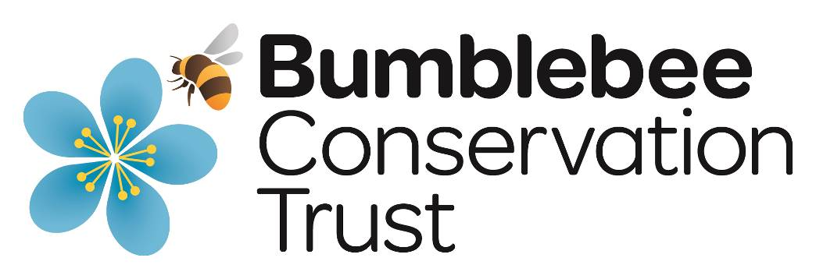

Application Pack

Land Management Advisor
Advertised January 2022

Contents

- Job Advert
- About the Bumblebee Conservation Trust
- Job description
- Person specification
- Summary of terms and conditions of employment
- Recruitment and selection process
- How to Apply
- Application Form
- Equal Opportunities Form

Job Advert

A unique opportunity to join a successful and growing conservation charity!  Land Management Advisor  Salary £21-23,000 per annum  The Bumblebee Conservation Trust (the Trust) is looking for a full-time Land Management Advisor to play a vital role in enhancing bumblebee habitat through our land management consultancy work.  Your primary role will be to provide land management advice for bumblebees to a variety of clients on a consultancy basis.  In this new role you will work closely with the Senior Partnerships Officer (also a new role) to enhance the Trust’s income through business relationships, whilst helping to achieve our strategic aim to create, restore and enhance bumblebee habitat. You will provide a professional advisory service to our consultancy clients and help inspire further support for the Trust through long term relationships.  You will be a dynamic, self-reliant individual with a track record of ecological assessment and an interest in invertebrates. You will be able to apply your ecological knowledge in a wide range of contexts to meet the needs of clients whilst ensuring bumblebees will benefit.  You will have strong communication skills, including via remote media, and be able to inspire a range of audiences to follow the advice given.  You will have experience of developing and maintaining effective relationships with business clients.  Please refer to the job description and person specification for more details of the role.  This is a full-time, permanent position, home-based with the option of hybrid working at the Trust’s offices in Stirling or Eastleigh.  The Trust recruits, employs, trains and promotes regardless of race, religion, colour, national origin, gender, disability, age, and other protected status.  At the Trust, we have a clear goal: to be the place where a diverse mix of talented people want to come, to stay and do their best work. We pride ourselves on reaching for our vision – to reverse the decline in bumblebees, through the hard work and dedication of our passionate and creative employees.  The closing date is 9.00am Monday 21st Feb. | 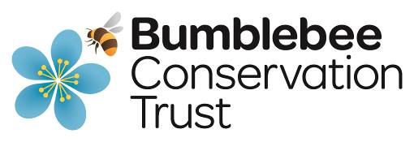  For an application pack please visit our website:  bumblebeeconservation.org/vacancies/  Bumblebee Conservation Trust  Beta Centre  Stirling University Innovation Park  Stirling FK9 4NF  Tel: 01786 594 128  recruitment@bumblebeeconservation.org  Charity numbers: 1115634; SC042830  To discuss the post informally, please contact:  Amy Plowman, Head of Conservation and Science  Tel. 07497 347 359  amy.plowman@bumblebeeconservation.org  Closing Date:  9.00am Monday 21st Feb 2022  Interview date:  Weds 9th March, remotely
About the Bumblebee Conservation Trust

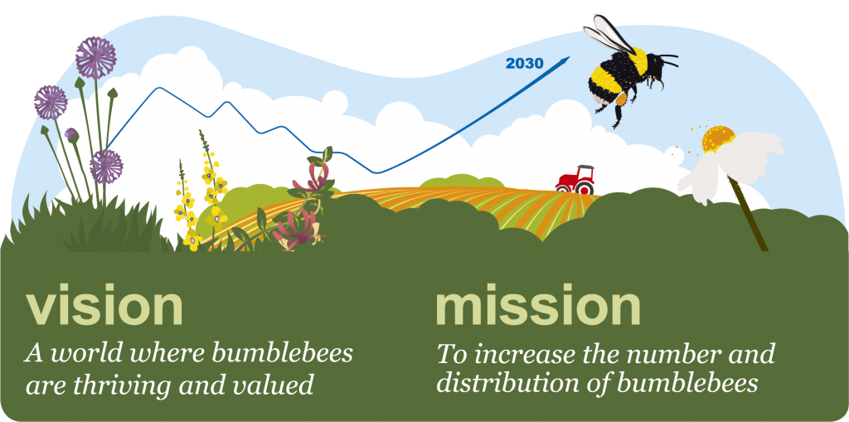

The Bumblebee Conservation Trust was established in May 2006 in response to ongoing declines in many bumblebee species, due primarily to habitat loss through agricultural intensification. In the last 80 years two species have become nationally extinct whilst populations of several others have crashed dramatically. Over one third of social bumblebee species are now regarded as species of principal importance under the UK Post-2010 Biodiversity Framework.

Bumblebees are ‘keystone’ pollinators, integral to our natural environment, and providing significant economic benefits through pollination of crops. We aim to help bumblebees and the habitats that they depend on through conservation and education.

For more information about our work, visit our website (http://bumblebeeconservation.org).

About the role
The Trust is experiencing unprecedented demand from businesses and other organisations wanting land management advice from a well-respected charity and proven authority on bumblebee conservation. At the same time the Trust is embarking on an exciting period of development and growth and to facilitate this, we need to grow our income.

This new role will increase the capacity of the Conservation and Science team to provide land management advice and respond to this increased demand. This will primarily be to clients on a consultancy basis but will also include some cases as part of our funded projects alongside the work of our Conservation Officers.

The role will interact closely with the Fundraising team, especially the new Senior Partnerships Officer, to grow income from large businesses through consultancy work and inspiring longer-term support from those businesses.

Job Description

Job Title: Land Management Advisor

Reporting to: Senior Conservation Officer

Responsible for: None

Hours: Full-time (35 hours a week), permanent position based at home with the option of hybrid working at the Trust’s Stirling or Eastleigh offices. Travel and overnight stays across England, Scotland and Wales will be expected.

Job purpose:
- Provide an effective land management advisory service on a consultancy basis that meets clients’ needs and delivers benefits for bumblebees across a wide variety of land use types
- Conduct site assessment visits and deliver bespoke land management advice in agreed formats according to client contracts, including written reports and in person presentations
- Work with the Senior Partnerships Officer to develop mutually beneficial relationships and increase income through existing and new corporate partnerships and consultancy clients
- Respond to land management enquiries and work with the Senior Conservation Officer to revise existing, and create new, land management resources for a range of land use types.
- Support the Trust’s Conservation Team with habitat and bumblebee assessment and monitoring on agreed sites within their project areas

Main responsibilities:
Land management advice and corporate partnerships
- Develop and deliver a professional approach to land management consultancy work that meets the needs of clients and has a positive impact on bumblebee habitat and populations
- Conduct site assessment visits and provide written and/or oral reports as agreed with clients
- Provide colleagues with templates and guidance for carrying out land management consultancy work when it is more efficient for others to do this and maintain records of all advice activities to allow effective internal monitoring and reporting
- Ensure that effective relationships with consultancy clients are maintained
- With the Senior Partnerships Officer actively seek to increase income through consultancy and corporate partnership work

Conservation Team support
- Be the lead contact for enquiries related to land management advice outside of project areas
- With the Senior Conservation Officer review, revise and create new land management advice resources for a wide range of land use types
- Assist conservation and project officers with habitat and bumblebee assessment and
monitoring within project areas.

Policy and profile
- Keep abreast of policy developments that will impact land management eg AES, BNG
- Contribute to development of internal and external position statements and policies related to land management
- Raise awareness of the Trust and its work at events, shows, conferences, workshops, lectures etc.
- To actively support the Trust’s social media.

General
- Contribute to the overall outputs of the BBCT team and carry out duties with due regard to the well-being and safety of others at all times.
- Undertake any other duties commensurate with the nature of the post as deemed appropriate and by agreement with the CEO.

Person Specification

Essential
- An environmental, ecological or agricultural degree, or equivalent experience
- Excellent knowledge of pollinator ecology, especially bumblebee habitat requirements
- Experience of ecological assessment, especially botanical and invertebrate, across a range of habitats
- Ability to deliver land management advice for a wide range of land use types including agricultural, industrial (eg quarries, solar parks), amenity, public open spaces and gardens
- Good understanding of UK land management and related policy frameworks, including agri-environment schemes, planning and biodiversity net gain, carbon offsetting etc.
- Ability to build strong relationships and work effectively with business clients
- Ability to plan and prioritise own workload with minimum supervision.
- Excellent verbal and written communication skills and experience in delivering land management advice in a variety of media.
- Computer literate including confident use of MS Outlook, Word, Excel and PowerPoint.
- Full driving licence and access to own vehicle with a willingness to travel across the UK.
- Ability to self-motivate and willingness to work remotely.
- Willingness to work some weekends and evenings, with overnight stays away from home on occasion.

Desirable
- Invertebrate and/or botanical identification skills qualification eg FISC level 3
- Ability to think creatively and use own initiative.
- Experience of working effectively in partnership with other organisations.
- Knowledge and demonstrable experience of using Geographic Information Systems (GIS) such as ArcGIS or QGIS.
- Excellent interpersonal skills, including the ability to negotiate, influence, motivate and support.

Summary of terms and conditions of employment

Terms and conditions: This is a full-time permanent post

Salary: £21-23,000 per annum

Pension: This post is eligible for the BBCT pension scheme (8% Employer contribution).

Location: Home-based with the option of hybrid working at Stirling or Eastleigh

Hours of work: The post holder will be employed full-time for 35 hours per week. Some overtime work may be required and a flexitime system is in place.

Annual leave: Annual entitlement of 35 days (on a pro rata basis for part-time staff) inclusive of Bank/Public Holidays.

Policies and procedures: We have policies designed to ensure the safety and well-being of both workers and volunteers e.g. health and safety, lone working.

Other benefits: The Trust provides Death in Service insurance to all employees, calculated as two times salary. Well-being support is provided via access to Health Assured’s Employee Assistance Programme.

The Trust recruits, employs, trains and promotes regardless of race, religion, colour, national origin, gender, disability, age, and other protected status.

At the Trust, we have a clear goal: to be the place where a diverse mix of talented people want to come, to stay and do their best work. We pride ourselves on reaching for our vision – to reverse the decline in bumblebees, through the hard work and dedication of our passionate and creative employees.

Recruitment and Selection Process

The Bumblebee Conservation Trust is an Equal Opportunities employer. This means that whilst seeking employment or during such employment with the Trust, we will seek to ensure equality of treatment for all persons regardless of sex, race, age, marital or civil partnership status, disability, religion or belief, sexual orientation, gender reassignment, pregnancy or maternity status.

Pre-employment checks:

We will require a minimum of two appropriate references and will check original documents proving your qualifications, identity, and right to live and work in the UK before you can start work with us.

You will be asked to complete our Criminal Record Declaration Form, however, a person’s criminal record, in itself, will not debar that person from being appointed to a post.

References:

Referees should ideally be your present and last employer. They should have had either managerial or supervisory responsibility for your work, and not be colleagues, subordinates or friends. If this is your first employment, a tutor’s reference and a personal reference or similar will be acceptable.
If you have any questions about providing reference details, please contact us.
BBCT will only approach your referees once an offer of employment has been made; they will be provided with a copy of the job description and asked to return a Reference Request Form.

How we use your personal information:

The information which we gather from you during the recruitment and selection process is retained and processed in accordance with the provisions set out by the Data Protection Act 1998 (DPA) and further to the General Data Protection Regulations (GDPR).
Please note that by submitting an application for employment, you are accepting that you have read and understood our Data Protection and Privacy Policy for Job Applicants (https://www.bumblebeeconservation.org/wp-content/uploads/2017/05/Data-Protection-and-Privacy-Policy-for-Job-Applicants-July-2018.pdf)
If you have any questions about how we use your data, please contact us.

How to Apply

If you are interested in joining us, please complete the application form below and return by email to recruitment@bumblebeeconservation.org no later than 9.00am on Monday 21st Feb 2022. You will receive confirmation we have received your application, and we will contact you to let you know if your application is being progressed to the interview stage.

In order to ensure that all applicants are assessed equally and fairly, applications will only be accepted on the form provided. Please do not send CVs.

Interviews are expected to take place on Weds 9th March 2022, via Zoom or Teams.

Application Form

PRIVATE AND CONFIDENTIAL
APPLICATION FOR THE POST OF:
Land Management Advisor

CLOSING DATE:
9am Weds 21st March 2022
INSTRUCTIONS FOR COMPLETION:
- Complete using black ink (block capitals)
or typescript (normal case)
- Answer all questions
- Do not attach a C.V.
PLEASE RETURN COMPLETED FORM TO:
recruitment@bumblebeeconservation.org
OR:- Recruitment, Bumblebee Conservation Trust
Beta Centre, Stirling University Innovation Park,
FK9 4NF

APPLICANT INFORMATION
TITLE: | SURNAME: |  | FORENAME(S):
ADDRESS (including postcode):

DAYTIME TELEPHONE NUMBER: |  | EVENING TELEPHONE NUMBER:
EMAIL ADDRESS:

CAN YOU PROVIDE PROOF OF YOUR RIGHT TO LIVE AND WORK IN THE UK?

Yes No (please tick/double click to select)

DO YOU HOLD A FULL CLEAN DRIVING LICENCE?

Yes No (please tick/double click to select)

DO YOU HAVE ACCESS TO A CAR TO USE AT WORK?

Yes No (please tick/double click to select)

IF YOU HAVE A DISABILITY WILL YOU REQUIRE ANY REASONABLE ADJUSTMENTS MADE TO ENABLE YOU TO ATTEND AN INTERVIEW?

Yes N/A (please tick/double click to select)

If yes please provide details:

EMPLOYMENT HISTORY
PRESENT OR MOST RECENT EMPLOYMENT
DATE FROM: | DATE TO:
JOB TITLE: | COMPANY NAME:
DUTIES & RESPONSIBILITIES:

SALARY: | FULL TIME PART TIME  (please tick/double click to select)
REASON FOR LEAVING:

IF STILL EMPLOYED PLEASE STATE NOTICE PERIOD REQUIRED:

PREVIOUS EMPLOYMENT OR RELEVANT VOLUNTEERING EXPERIENCE
Please continue on a separate sheet if necessary
DATE FROM: | DATE TO:
JOB TITLE: | COMPANY NAME:
DUTIES & RESPONSIBILITIES:

SALARY: | FULL TIME PART TIME  (please tick/double click to select)
REASON FOR LEAVING:

DATE FROM: | DATE TO:
JOB TITLE: | COMPANY NAME:
DUTIES & RESPONSIBILITIES:

SALARY: | FULL TIME PART TIME  (please tick/double click to select)
REASON FOR LEAVING:

DATE FROM: | DATE TO:
JOB TITLE: | COMPANY NAME:
DUTIES & RESPONSIBILITIES:

SALARY: | FULL TIME PART TIME  (please tick/double click to select)
REASON FOR LEAVING:

DATE FROM: | DATE TO:
JOB TITLE: | COMPANY NAME:
DUTIES & RESPONSIBILITIES:

SALARY: | FULL TIME PART TIME  (please tick/double click to select)
REASON FOR LEAVING:

DATE FROM: | DATE TO:
JOB TITLE: | COMPANY NAME:
DUTIES & RESPONSIBILITIES:

SALARY: | FULL TIME PART TIME  (please tick/double click to select)
REASON FOR LEAVING:

EDUCATION
DATE FROM: | DATE TO:
SCHOOL/COLLEGE/UNIVERSITY:
QUALIFICATIONS Please state level and grade obtained

DATE FROM: | DATE TO:
SCHOOL/COLLEGE/UNIVERSITY:
QUALIFICATIONS Please state level and grade obtained

DATE FROM: | DATE TO:
SCHOOL/COLLEGE/UNIVERSITY:
QUALIFICATIONS Please state level and grade obtained

TRAINING & DEVELOPMENT
DATE FROM: | DATE TO:
TRAINING INSTITUTE/AWARDING BODY:

QUALIFICATIONS Please state level and grade obtained

DATE FROM: | DATE TO:
TRAINING INSTITUTE/AWARDING BODY:

QUALIFICATIONS Please state level and grade obtained

DATE FROM: | DATE TO:
TRAINING INSTITUTE/AWARDING BODY:

QUALIFICATIONS Please state level and grade obtained

MEMBERSHIP OF PROFESSIONAL BODIES (if applicable)
NAME OF INSTITUTE/PROFESSIONAL BODY:

MEMBERSHIP TYPE:

NAME OF INSTITUTE/PROFESSIONAL BODY:

MEMBERSHIP TYPE:

NAME OF INSTITUTE/PROFESSIONAL BODY:

MEMBERSHIP TYPE:

PERSONAL STATEMENT

Detail how your knowledge, skills and experience will enable you to fulfil the requirements of the post. Please refer to the job description and person specification when completing this section. You can also include details of any voluntary activities or interests, as well as any other relevant information you would like us to consider in support of your application.
PLEASE DO NOT EXCEED 2 SIDES OF A4 IN LENGTH.

REFERENCES
Please give details of TWO people who can confirm your suitability for this role. This should ideally include your present/most recent employer and not be related to you in any personal capacity (e.g. friends or family members). We will only approach referees if you are offered the post. If you cannot provide two references do not leave this section blank, please contact us.
TITLE: | SURNAME: |  | FORENAME(S):
JOB TITLE:
ADDRESS (including postcode):

DAYTIME TELEPHONE NUMBER: |  | EVENING TELEPHONE NUMBER:
EMAIL ADDRESS:

CAPACITY IN WHICH KNOWN TO YOU:
TITLE: | SURNAME: |  | FORENAME(S):
JOB TITLE:
ADDRESS (including postcode):

DAYTIME TELEPHONE NUMBER: |  | EVENING TELEPHONE NUMBER:
EMAIL ADDRESS:

CAPACITY IN WHICH KNOWN TO YOU:

DECLARATION
Agreement to use my data
- I hereby freely give the Bumblebee Conservation Trust consent to process, store and use my personal data relating to my job application in accordance with the Data Protection and Privacy Policy for Job Applicants (https://www.bumblebeeconservation.org/wp-content/uploads/2017/05/Data-Protection-and-Privacy-Policy-for-Job-Applicants-July-2018.pdf)
- I confirm that, to the best of my knowledge, the information on this form is correct.
- I accept that if any of the enclosed information is found to be untrue after my appointment, I may be liable for dismissal without notice.
- I authorise you to contact the references listed on this form and make any other checks deemed appropriate once an offer of employment is made.
In giving my consent:
- I understand that I can ask to see this data to check its accuracy at any time via a subject access request (SAR).
- I understand that I can ask for a copy of my personal data held about me at any time, and this request is free of charge.
- I understand that I can request that data that is no longer required to be held can be removed from my file and destroyed.
- I understand that if I am unsuccessful with my application my data will be destroyed after 6 months.
NAME (PLEASE PRINT):

SIGNATURE:

DATE:

Please also complete and return the separate Equal Opportunities Monitoring Form below.

How we use this information:

- This form will be detached from your application on receipt.

- It will be kept strictly confidential and is completely anonymous.

- This form is stored separately from the application.

- It is not viewed during the short-listing process.

- It will not form any part of the recruitment process or decision to appoint.

- This information will be used to provide data for monitoring purposes only.

Equal Opportunities Monitoring Form

PRIVATE AND CONFIDENTIAL
The Bumblebee Conservation Trust is an Equal Opportunities employer. This means that whilst seeking employment or during such employment with the Trust, we will seek to ensure equality of treatment for all persons regardless of sex, race, age, marital or civil partnership status, disability, religion or belief, sexual orientation, gender reassignment, pregnancy or maternity status.
You may choose to leave any or all questions unanswered.
TYPE OF ROLE APPLIED FOR: | CONSERVATION SCIENCE  ADMINISTRATION FINANCE  COMMUNICATIONS PUBLIC ENGAGEMENT  STRATEGY
DATE FORM COMPLETED: |  | AGE:
GENDER  (Please circle/cross out as appropriate): | MALE  FEMALE  TRANSGENDER  OTHER  (Please specify)________________ | IS THIS THE SAME GENDER YOU WERE ASSIGNED AT BIRTH? | Yes  No  (please tick/double click to select)
MARITAL STATUS (Please circle/cross out as appropriate): | MARRIED  CIVIL PARTNERSHIP  SINGLE  DIVORCED  LIVING WITH PARTNER  OTHER (Please specify)______________________________
DO YOU HAVE RESPONSIBILITY FOR DEPENDANTS (e.g. children, elderly, or any other person for whom you are the main carer)? | CHILDREN  ELDERLY  OTHER  NOT APPLICABLE
DISABILITY  Do you consider yourself to have a physical and/or mental impairment as defined by the Equality Act 2010/ Disability Discrimination Act 1995 (NI)? | Yes No (please tick/double click to select)  Please give details if you wish:
ETHNIC ORIGIN  How would you describe your identity? | WHITE:  BRITISH  ENGLISH  IRISH  SCOTTISH  WELSH  OTHER (PLEASE SPECIFY): _____________________________  MIXED:  WHITE AND BLACK CARIBBEAN  WHITE AND BLACK AFRICAN  WHITE AND ASIAN  OTHER (PLEASE SPECIFY): _____________________________  ASIAN, ASIAN BRITISH, ASIAN ENGLISH, ASIAN SCOTTISH ASIAN IRISH OR ASIAN WELSH (Delete as applicable):  INDIAN  PAKISTANI  BANGLADESHI  OTHER (PLEASE SPECIFY): _____________________________  BLACK, BLACK BRITISH, BLACK ENGLISH, BLACK SCOTTISH, BLACK IRISH, BLACK WELSH (Delete as applicable):  CARIBBEAN  AFRICAN  OTHER (PLEASE SPECIFY): _____________________________  CHINESE, CHINESE BRITISH, CHINESE ENGLISH, CHINESE SCOTTISH, CHINESE IRISH, CHINESE WELSH (Delete as applicable):  CHINESE  OTHER (PLEASE SPECIFY): _____________________________  OTHER ETHNIC ORIGIN:  (PLEASE SPECIFY): ____________________________________
RELIGION/CULTURAL BACKGROUND | NONE  CHRISTIAN  BUDDHIST  HINDU  JEWISH  MUSLIM  SIKH  OTHER (PLEASE SPECIFY): _____________________________
WHERE DID YOU SEE THIS POST ADVERTISED?
Please include URL if possible

Thank you for taking the time to complete this form. Please return to recruitment@bumblebeeconservation.org

