February 2019

Our Ref: Recruitment/EcoFeb2019/Warrington

Dear Applicant,

SENIOR / PRINCIPAL ECOLOGIST - WARRINGTON

Thank you for your interest in the above post. This letter encloses the following:

- Information about the post
- Application form

If you are interested in applying, please would you send the following:

- Completed application form
- Curriculum vitae

Following review of the applications, a short list of candidates will be contacted for interview. If you would like to talk more informally, please do not hesitate to contact the office and ask to speak to me or Katie Shilcock (Tel: 01925 844 004).

I look forward to hearing from you. Please submit applications by post, or by email to recruitment@tep.uk.com. The closing date is 5pm Thursday February 28th 2019.

Yours sincerely,

Elizabeth Seal

Elizabeth Seal
Director
TEP

Enc: Job Details and Application Form
Senior / Principal Ecologist

The Opportunity
We are looking for an experienced ecologist to manage a variety of ecological survey and assessment projects. You will be based in our head office in Warrington working in our award-winning ecology team. Your work will be primarily in North West England and North Wales, but there will be opportunities to work on projects around the UK. Requests to be based at one of our other offices will be considered.
This opportunity would appeal to someone with at least four years’ relevant consultancy experience with a range of survey skills and knowledge of ecology in the planning system.
Our ecologists are a close-knit team, promoting knowledge sharing and support. We have a strong focus on continual development providing informal and structured training and encouraging staff to progress through the CIEEM membership levels and obtain Chartered status.
You will work alongside colleagues from other environmental professions including landscape designers, arborists, planners, archaeologists and landscape managers. This is a permanent position offering you the opportunity to grow quickly in your ecological career.
The Company
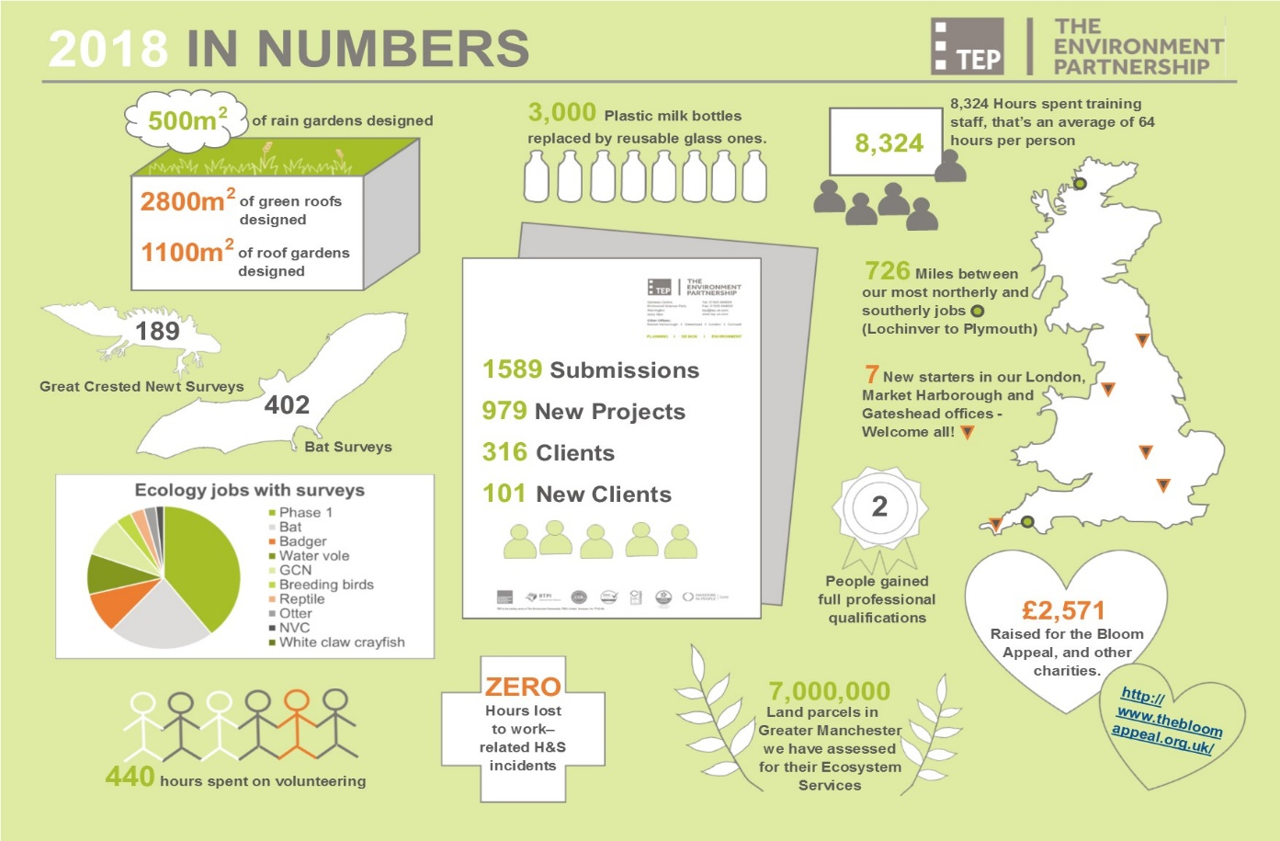
TEP is an award-winning multi-disciplinary environmental practice with offices in Warrington, London, Market Harborough, Gateshead and Cornwall. We have 130 members of staff, all of whom are environmentalists. We set ourselves the highest standards in sustainability and are Gold Standard Investors In People and are the only environmental consultancy to be fully carbon-neutral. We offer a range of benefits including flexible working hours, income protection, generous pension scheme, social events and promote employee involvement with community projects.

The Role and Requirements
The successful candidate must be able to demonstrate:
- Self-management skills, overseeing a busy and varied workload, supervising field staff and co-ordinating project work with other professionals in TEP;
- attention to detail and accuracy, particularly in respect of quality assurance, delivery of contracts on time and within budget, and checking the quality of work produced by those you manage;
- high levels of written and verbal communication;
- experience of contributing to meetings with clients and design teams.
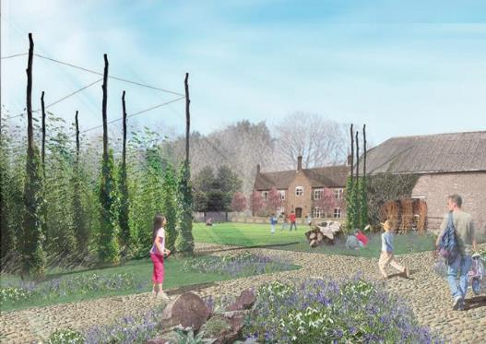
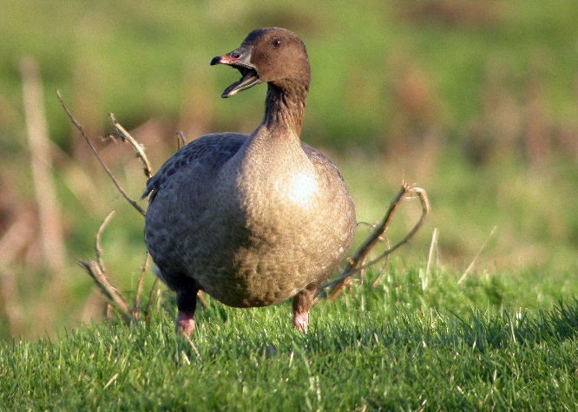
Our diverse client base includes Homes England, National Grid, many Local Authorities, National Trust, United Utilities, renewable energy providers and house builders. Our website www.tep.uk.com shows the breadth of our work. One current major commission is the ecological assessment and design for a new 100ha country park in Hampshire, alongside landscape designs and EIA for a 2,500 home urban extension. Another achievement is the design, implementation and management of a 110ha Farmland Conservation Area and Nature Park in Lancashire, established as mitigation for a1000 house development and a 4km link road. The FCA sustains internationally important populations of whooper swans and pink-footed geese.
Our Vision for the Country Park in Hampshire
Pink-footed goose on Lancashire farmland

Person Specification
Essential:

- Degree or equivalent in relevant ecology discipline
- Associate or higher Membership of CIEEM
- Skilled in phase 1 habitat survey and/or protected species surveys
- Demonstrable experience in writing Ecological Impact Assessments
- Knowledge of the planning process
- Experience of writing EIA documents
- Demonstrable ability of organising and leading surveys
- Strong written communication skills
- Attention to detail
- Good team player, with the ability to work independently
- Ability to work to deadlines and prioritise competing requirements
- Valid UK Driving Licence

Desirable:

- Experience of writing HRA documents
- Ornithology knowledge
- Botanical skills to FISC Level 3
- Holding a survey or development licence for protected species
- Competency in GIS (preferably ARC)

Equal Opportunities
TEP is an equal opportunities employer and is positive about disabled people. We will guarantee an interview for all disabled candidates meeting the eligibility criteria.

To Apply
Please send your completed application form and CV to recruitment@tep.uk.com.

Closing Date
Closing date for receipt of applications is 5pm Thursday 28th February 2019.

Dates of Interview
We hope to hold interviews on Friday 8th and/or Monday 11th March 2019. Let us know if these dates are going to be difficult for you.

1. Personal Details

Name
Address for correspondence
(inc postcode)

Telephone Number

Email address
National Insurance No.

2. The Post

Post applied for:
How did you hear about the post?
Briefly tell us about your career to date, your skills and the special attributes you can bring to TEP.
You can provide your answer here, or use a separate sheet. Don’t worry if the text spills over into a separate page.

3. Education and Referees – either fill in details below or refer to your CV (we will verify the authenticity of any qualifications stated on this form)

College or University attended  (State Dates) | Degree, diplomas etc. obtained  (State grades)

Please give details of membership of any professional institutions or societies (and membership number, if known) relevant to the position applied for
Please provide a name and contact details for two referees who can comment on your professional skills and work experience. One should normally be your present or most recent employer.  We will not contact your referees without your permission | Referee 1 | Referee 2

4. Present or Last Employment

Please provide the name, address & telephone number of Company; and a contact name – we will only contact your employer with your permission |  |  |  | Position held | Reason for leaving or wishing to leave | Current/ Last Salary, pension/benefits package and Annual Leave Allowance
Contact name

Tel:

Email:
Dates employed: | From  Month/  Year |  | To  Month/  Year

5. Previous Employment – if present or last employment was under 3 years please provide employment details to cover this period. If unemployed, please state period of unemployment.

Name and address of Company | Dates employed |  | Position held |  | Reason for leaving
 | From  Month/  Year | To  Month/  Year

6. Other Information

Do you hold a full valid UK driving licence, with 8 or fewer penalty points? | Yes |  | No |  | Comment:
Are you eligible to work in the UK? | Yes |  | No |  | Comment:
Have you undergone a DBS check* (Basic Disclosure) in the last 12 months? | Yes |  | No
If Yes, please give date:

Have you undergone a screening test for Drugs & Alcohol* in the last 12 months? | Yes |  | No
If Yes, please give date:

* Due to client requirements, if successful in your application you will be required to complete a DBS (Basic Disclosure) check and undertake a drugs & alcohol screening test as a condition of employment. If you have this information already, you will need to provide copies of the results to be held in your personnel file.

Equal Opportunities – TEP is an Investor in People. We operate an Equal Opportunities Policy and seek to ensure opportunities for everyone to work safely and maximise their abilities.

Do you consider yourself to have a disability or long-term health condition? | Yes |  | No
Could we make any special provisions to assist during interview or in your work if successful? | Yes |  | No |  | Details:

I confirm that the information I have provided is true and complete to the best of my knowledge.

SIGNED:

NAME:

DATE:

Please send the completed form together with a recent copy of your CV to recruitment@tep.uk.com

